Your Name (optional): _____________________________ Job Title: ______________________________________

Date: __________________________ Location: ___________________________________

Instructions: Circle the best answer for each question.
Did you take this exam at the beginning of the day? ___Yes ___No

- What pest is this?
A. Cockroach
B. Mouse
C. Rat

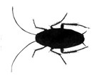
- What pest is this?
A. Cockroach
B. Mouse
C. Bed Bug

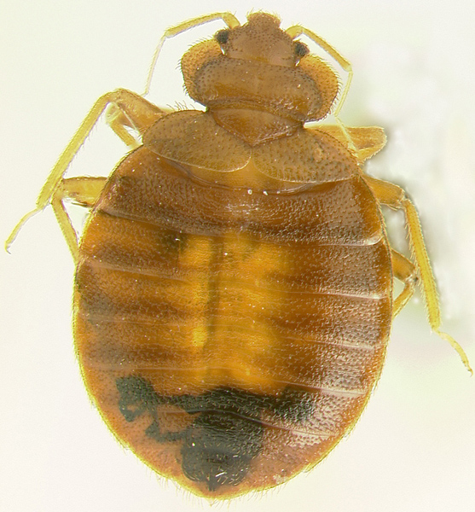
- What pest is this?
A. Cockroach
B. Mouse
C. Bed Bug

- How can cockroaches make people sick?
A. They cause Lyme disease
B. They trigger asthma attacks C. They cause heart disease

- Which item poses the LEAST risk of pesticide exposure to people?
A. Fogger set off in a kitchen
B. Bait in a station under the sink
C. Boric acid in piles on the floor

- Which product is NOT poisonous?
A. Snap trap
B. Pesticide spray
C. Insecticidal dust

- Why should pest-related problems be reported?
  - To document the problem so IPM team members can solve it
  - Reports keep staff busy
  - To budget for routine pesticide sprays
- Which item should be a part of the pest control contractor’s proposal?
  - Schedule for routine baiting
  - Instructions to residents on how to spray their units
  - A list of pesticides that may be used on the property

- What do pests need to survive?
A. Food, water, shelter
B. Food, gel bait, shelter
C. Food, water, gnawing

- When are household pests most active?
A. Morning
B. Afternoon
C. Night

- How do rodents usually travel?
A. Touching a wall
B. In groups
C. Avoiding dark areas

- How do mice react to a new trap?
A. They are curious and visit it
B. They avoid it for a week
C. They attack it

- Where do cockroaches usually hide?
A. Under carpet
B. In cracks and crevices
C. In brightly lit areas

- Which pest is most likely to be found on a mattress?
  - Rat
  - Bed bug
  - Mouse
- Which pest may gnaw electrical wires?
A. Cockroach
B. Mouse
C. Bed Bug

- Where should a snap trap be placed to catch a mouse?
  - Anywhere in the kitchen
  - Trigger end touching the wall along which they travel
  - In the middle of the floor

- Which IPM method helps manage an infestation of rats?
A. Mattress encasement
B. Rodenticide bait in tamper resistant stations
C. Pesticide spray

- Which IPM method helps manage bed bugs?
A. Mattress encasement
B. Boric Acid
C. Gel baits

- For which pest are some Pest Management Professionals using spray pesticides?
A. Rat
B. Mouse
C. Bed bug

- Approximately how fast do baits kill cockroaches?
A. Instantly
B. Within a month
C. After two months
- Which item may be used near cockroach bait?
A. Nicotine
B. Pesticide spray
C. Sticky trap

- At a multifamily property, who has the overall responsibility for the IPM program?
A. Property Manager/ IPM Coordinator
B. Pest Management Professional
C. Residents

- At a multifamily property, who generally repairs water leaks?
A. Maintenance Staff
B. Pest Management Professional
C. Residents

- How do residents participate in IPM?
  - Trim bushes and have cats
  - Keep food in containers and remove trash from their units
  - Apply pesticides weekly

- At a multifamily property, who has the overall responsibility to provide assistance to residents who cannot complete their responsibilities related to IPM?
A. Property Inspector
B. Pest Management Professional
C. Property Manager

